PRACTICAL-1: INTRODUCTION TO UNITY & VR DEVELOPMENT
Aim:
To install Unity Hub and Unity 2022.3.62f3 LTS, create the first Unity project, and understand the Unity Editor.
Theory:
Unity is a real-time game engine used for creating 2D, 3D, AR and VR applications. Before developing VR projects, students should first learn how to install Unity, create a project and understand the Unity Editor.
Procedure:
Step-1: Download Unity Hub from https://unity.com/ download.
Step-2: Install Unity Hub.
Step-3: Sign in with a Unity account.
Step-4: Go to Installs → Install Editor.
Step-5: Archive, Switch to 2022 Version and Select Unity 2022.3.62f3 LTS.
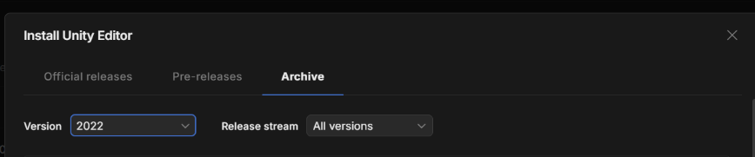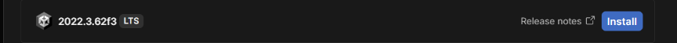
Step-6: Install Unity 2022.3.62f3 LTS and Microsoft Visual Studio.
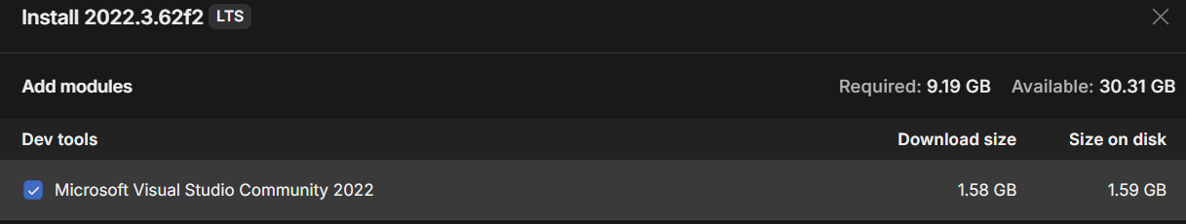
Step-7: Open Unity Hub and click New Project.
Step-8: Choose 3D (Core).
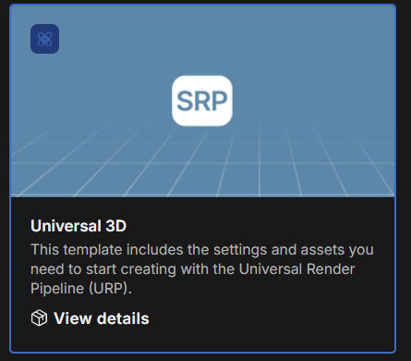
Step-9: Name the project 'VR_Practicals'.
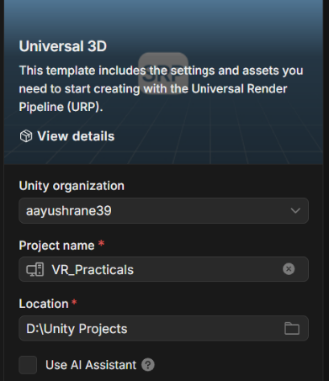
Step-11: Click Create Project.
Step-12: Observe the Hierarchy, Scene, Game, Inspector, Project and Console windows.
Step-13: Save the scene as MainScene.
Output:
Unity Hub and Unity 2022.3.62f1 LTS installed successfully. A new 3D Unity project named 'VR_Practicals' is created and the MainScene is saved.
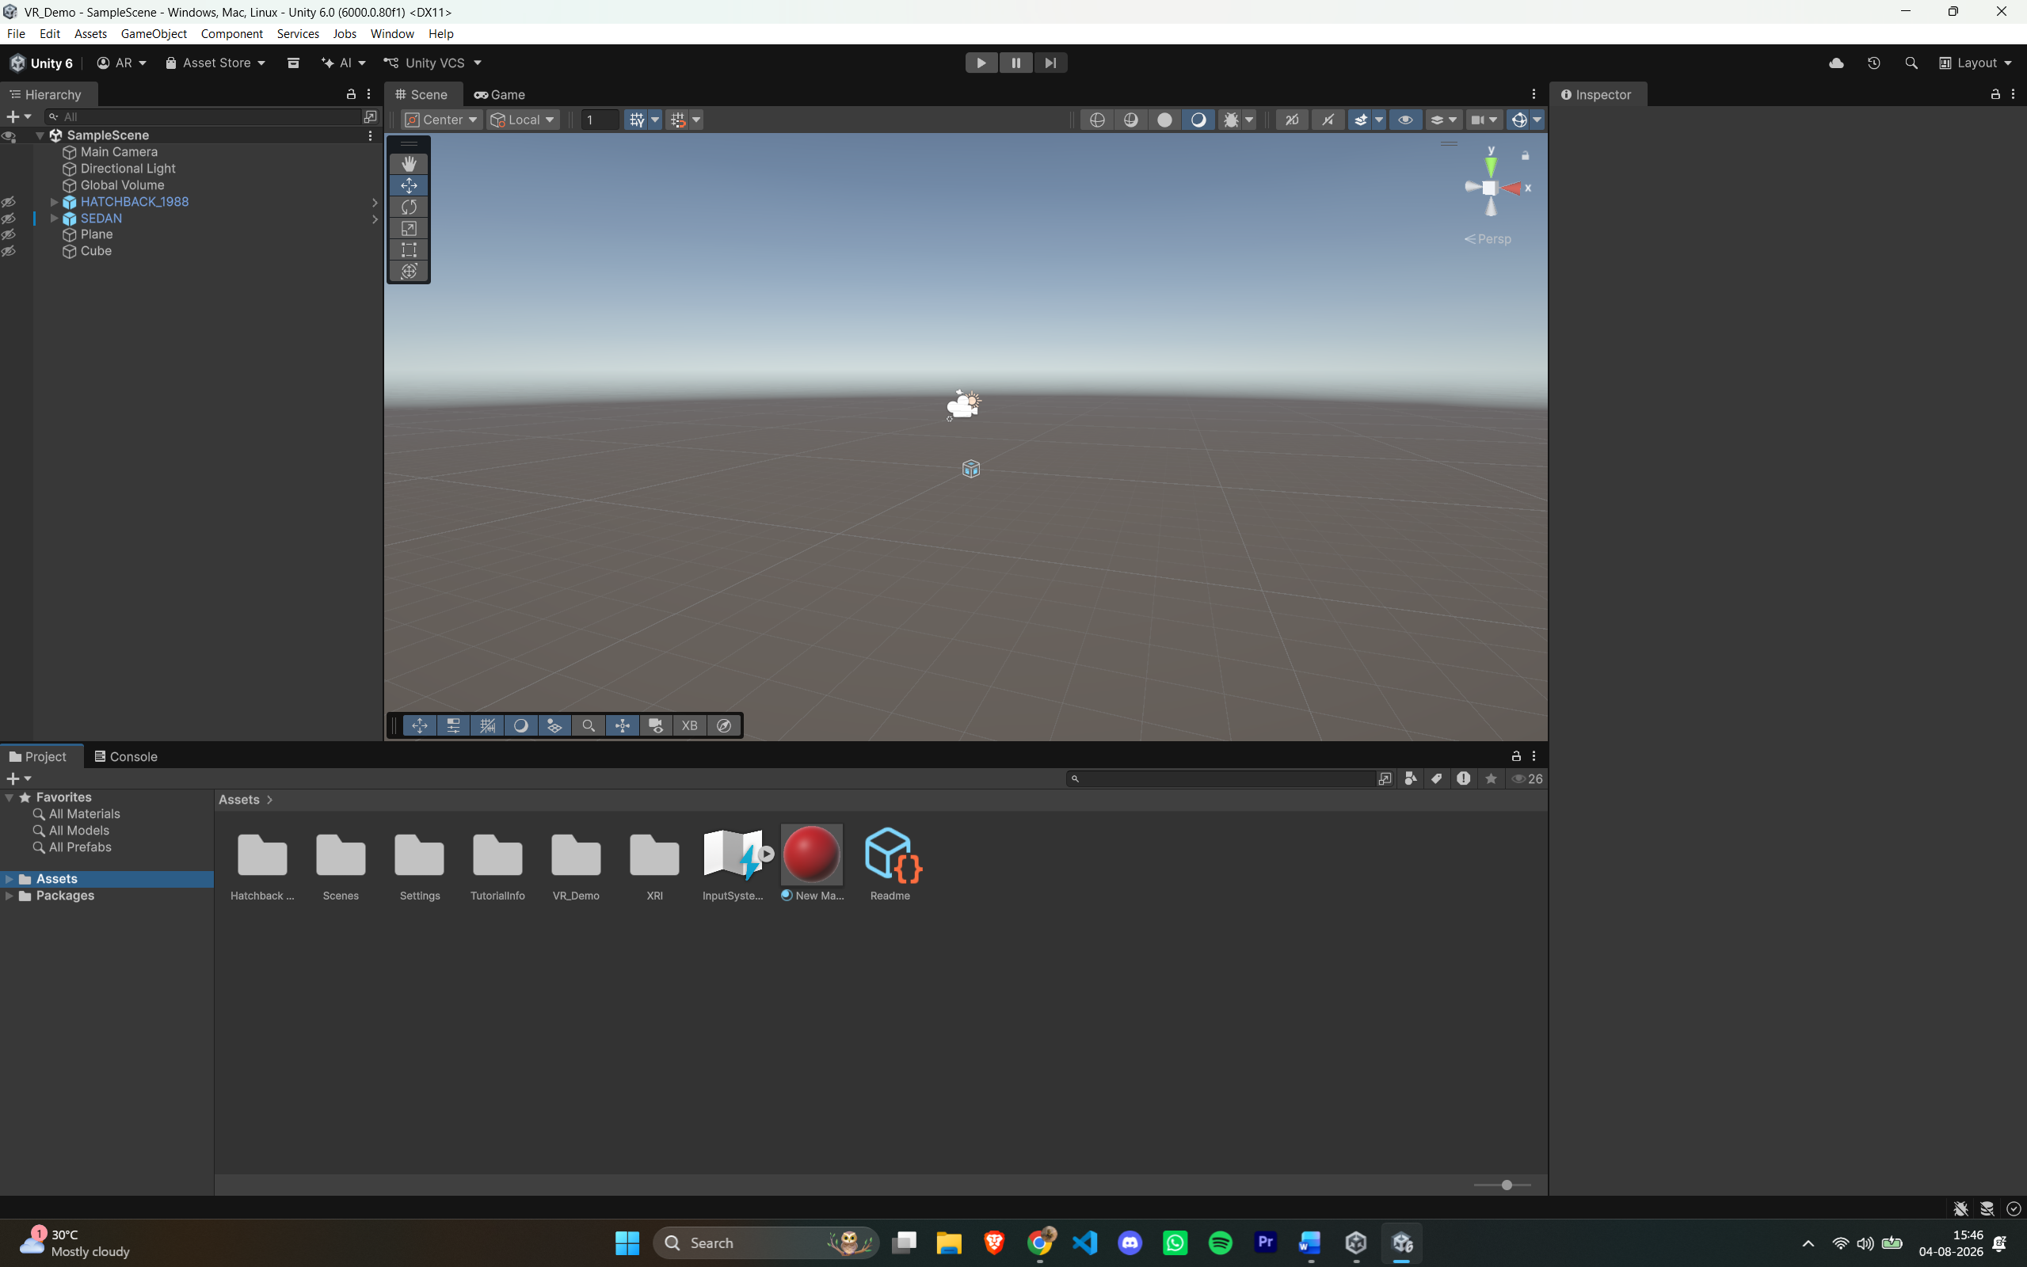

PRACTICAL-2: Designing VR UI
Aim:
To design a Puzzle Room game menu interface using Canva with a suitable title, tagline, and menu options.
Theory
Canva is a graphic design platform that can be used to create attractive game interfaces and visual layouts. It provides text, shapes, images, and design elements that can be arranged to create a professional interface. A properly organized game menu improves the visual appearance and user experience.

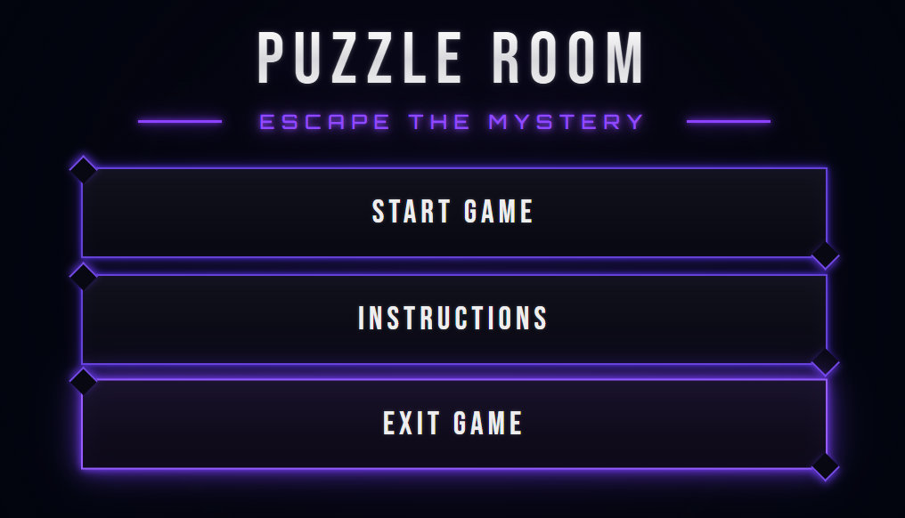

PRACTICAL-3-: Building a 3D Environment
Aim:
To create and design a basic 3D environment using Unity by adding and arranging 3D objects, applying materials, setting up lighting, and creating a suitable scene.
Theory:
Unity is a game development engine used to create interactive 2D and 3D applications. A 3D environment is created by arranging GameObjects, applying materials, and setting up lighting and cameras. Unity allows objects to be positioned, rotated, and scaled to create the required virtual environment.
Procedure:
Step-1: Create Project: Open Unity Hub and create a new 3D project.
Step-2: Create Scene: Open the newly created project and create or open a scene.
Step-3: Add Objects: Add the required 3D objects such as planes, cubes, spheres, or other GameObjects.
Step-4: Arrange Objects: Adjust the position, rotation, and scale of the objects using the Transform component.
Step-5: Apply Materials: Create or select suitable materials and apply them to the objects.
Step-6: Set Lighting: Add and configure suitable light sources to illuminate the 3D environment.
Step-7: Set Camera: Position the Main Camera to obtain a proper view of the complete environment.
Step-8: Save Scene: Save the completed scene and project.
Step-9: Click the Play button to run the scene and verify that the 3D environment is displayed correctly.

Output:

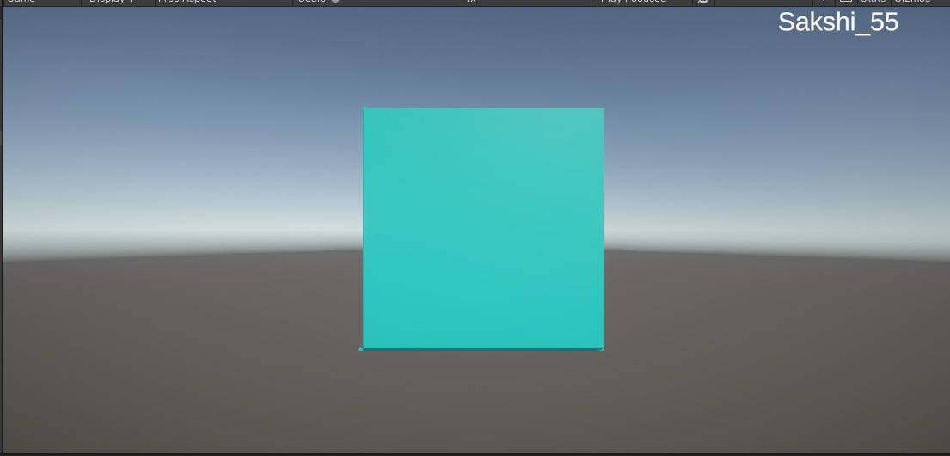

PRACTICAL-4 -: Importing Assets
Aim:
To create a basic 3D puzzle room environment in Unity using the Low Poly 3D Dungeon asset and by arranging and modifying the required dungeon components.
Theory:
Unity provides a 3D environment where pre-built assets can be imported and arranged to create interactive scenes. The Low Poly 3D Dungeon asset provides ready-made walls, pillars, materials, and scenes. These components can be modified and arranged in Unity to create a customized puzzle room.
Procedure:
Step-1: Add Assets: Go to Windows → Asset Store, search for Dungeon, select the free Low Poly 3D Dungeon asset, and add it to My Assets.
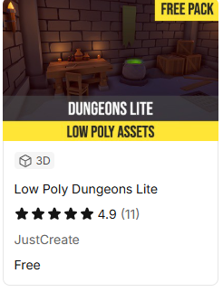
Step-2: Configure Materials: Open the folder containing the imported packages, go to the Material folder, select all the materials, and go to Edit → Rendering → Materials. Select the option containing URP.
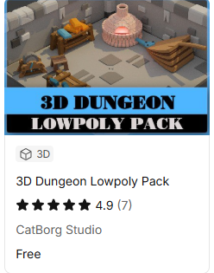
Step-3: Save the Scene: Select the Untitled scene and use Save Scene As to save it with the name Puzzle Room.
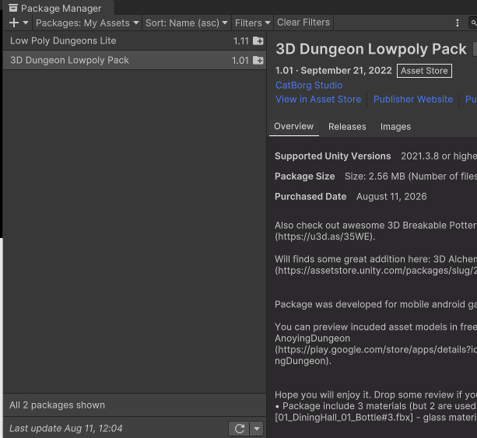
Step-4: Open Low Poly Dungeon: Go to Low Poly Dungeon → Scene and select the required dungeon scene.
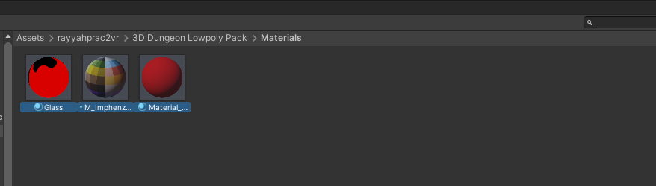
Step-5: Add Dungeon to Hierarchy: Drag the selected dungeon scene into the Hierarchy window.
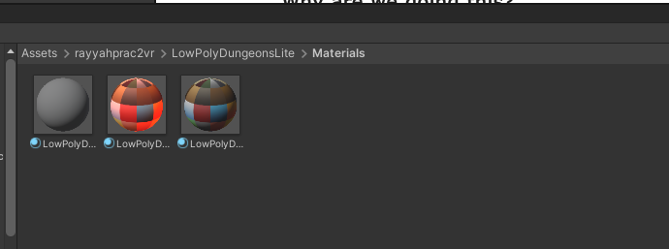
Step-7: Place Dungeon in Puzzle Room: Select Dungeon of the Low Poly and drag it into the Puzzle Room scene.
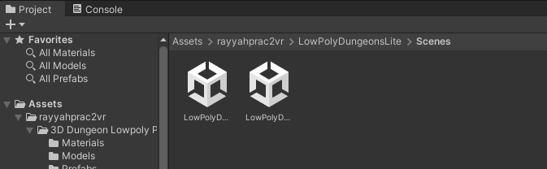
Step-8: Remove Original Scene: Select the Low Poly scene, click the three-dot menu, select Remove Scene, and choose not to save it.
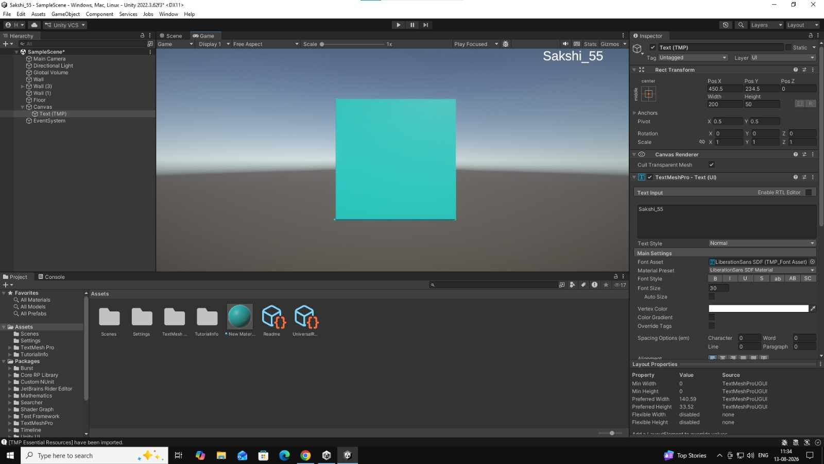
Step-8: Duplicate the Wall: Select one side of the wall along with the two pillars, press Ctrl + D, and drag using the blue line to position the duplicate and create the fourth wall.
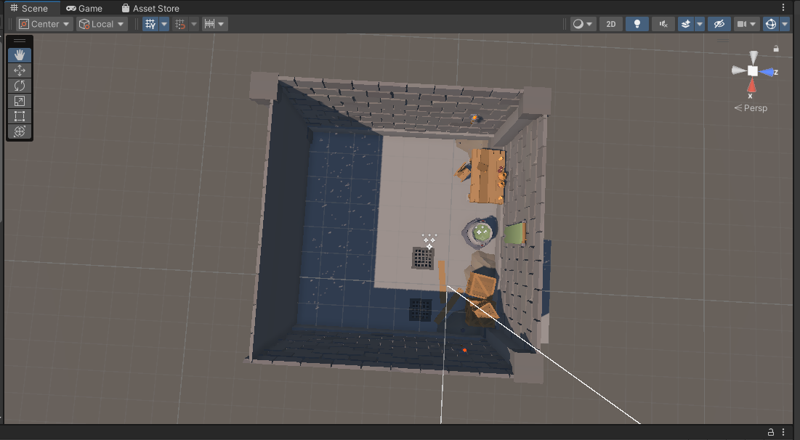

PRACTICAL-5: XR Device Simulator
Aim:
To set up the XR Interaction Toolkit and XR Device Simulator in Unity and configure the project for basic XR interaction.
Theory:
The XR Interaction Toolkit is a Unity package used to create interactive VR and AR experiences. It provides components for XR controllers, interaction systems, and input handling. The XR Device Simulator allows XR interactions to be tested within the Unity Editor without requiring a physical XR device.
Procedure:
Step-1: Install XR Interaction Toolkit: Open Window → Package Manager, select Unity Registry, search for XR Interaction Toolkit, install the package, select Yes when prompted to restart, and save the project.
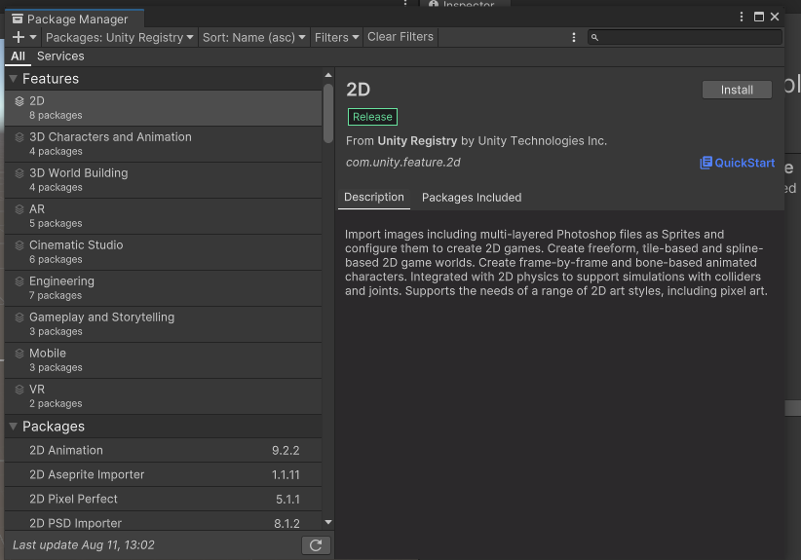
Step-2: Import Starter Assets: Open Package Manager → XR Interaction Toolkit → Samples and import Starter Assets and XR Device Simulator.
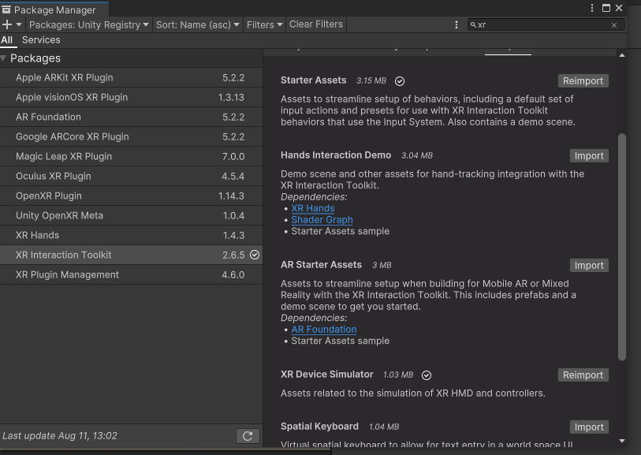
Step-3: Add XR Origin: Remove the existing Main Camera from the Hierarchy and drag the XR Origin into the Hierarchy window.
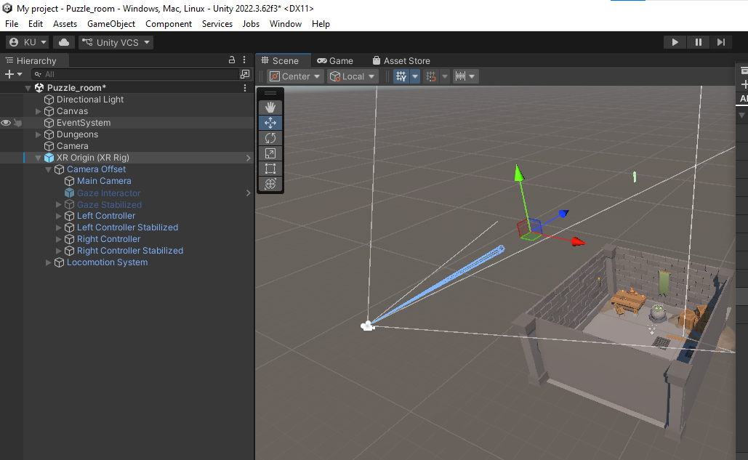
Step-4: Add XR Device Simulator: Add the XR Device Simulator to the Hierarchy window.
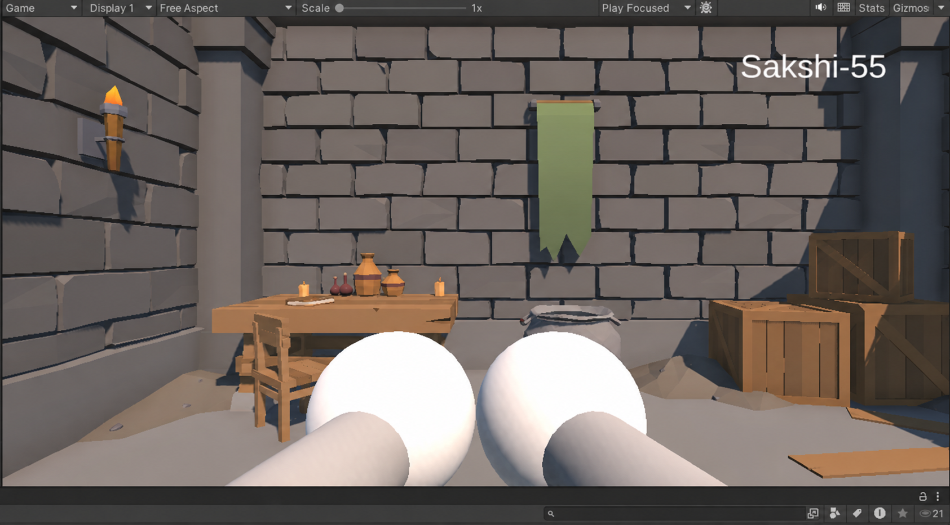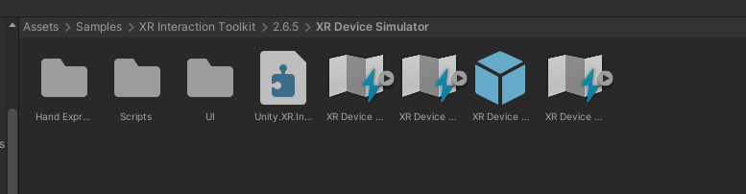

Step-5: Configure Input Action Manager: Add/configure the Input Action Manager required for handling XR input actions.
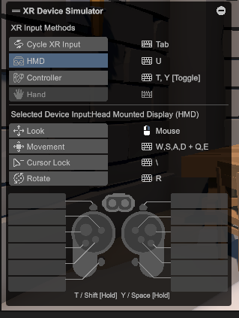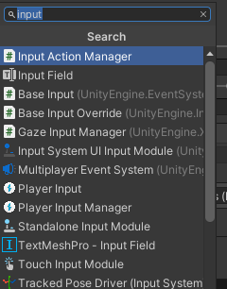
Step-6: Verify XR Components: Check the Hierarchy and ensure that the XR Device Simulator and required XR components are present.
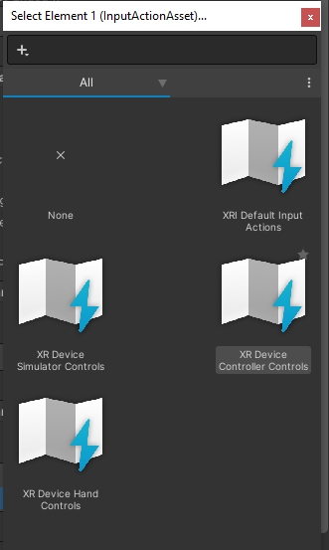

Step-7: Run the Project: Click the Play button to run the game and test the XR environment using the simulator.
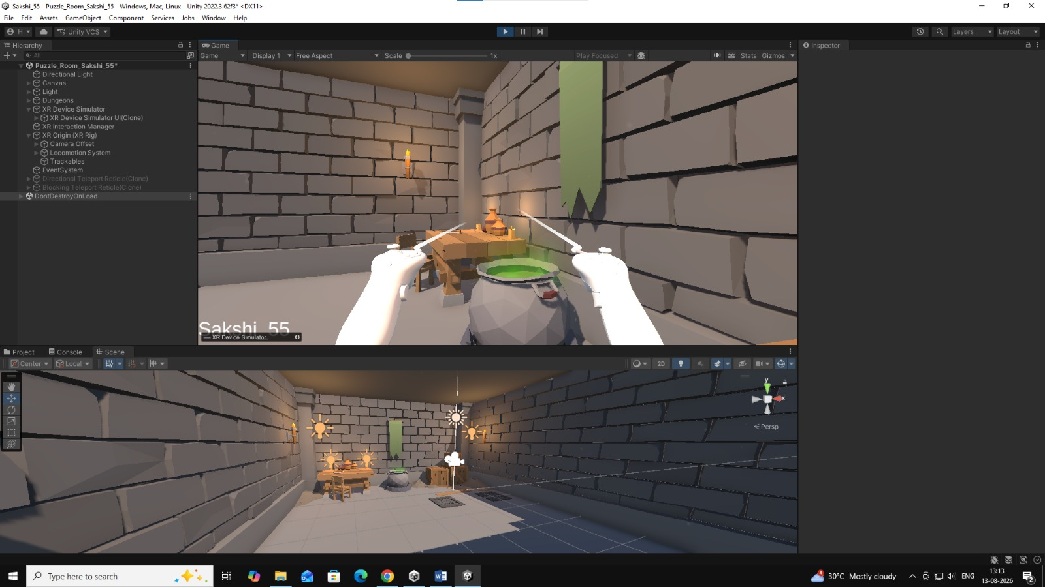

PRACTICAL-6: VR Locomotion
Aim:
To configure XR locomotion in Unity by adding the XR Locomotion System and Continuous Move Provider to enable movement in the XR environment.
Theory:
XR locomotion allows users to move around within a virtual environment using XR controllers. Unity's XR Interaction Toolkit provides locomotion components that can be configured for different movement methods. The Continuous Move Provider allows continuous movement based on the configured input actions.
Procedure:
Step-1: Install XR Interaction Toolkit: Go to Window → Package Manager, select Unity Registry, search for XR Interaction Toolkit, install it, restart Unity if prompted, and save the project.
Step-2: Import Starter Assets: Open XR Interaction Toolkit → Samples and import Starter Assets and XR Device Simulator.
Step-3: Add XR Origin: Remove the Main Camera and drag the XR Origin into the Hierarchy window.
Step-4: Add XR Simulator: Add the XR Device Simulator to the Hierarchy.
Step-5: Add Input Action Manager: Add the Input Action Manager and ensure the XR Device Simulator is present in the Hierarchy.
Step-6: Run the Project: Click the Play button to run the XR environment.
Step-7: Add Locomotion System: Go to GameObject → XR → Locomotion System and add the XR Locomotion System to the scene.
Step-8: Add Continuous Movement: Select the XR Locomotion System and add the Continuous Move Provider (Action-based) component.
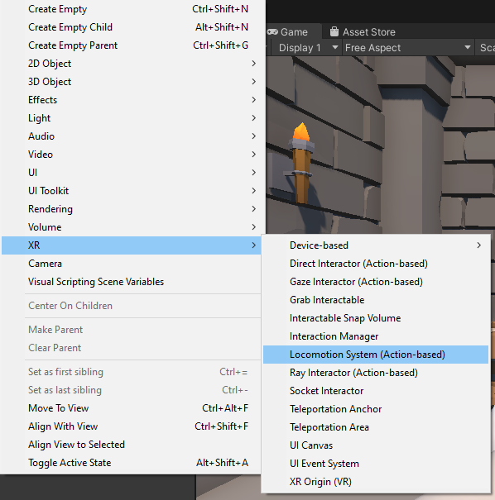 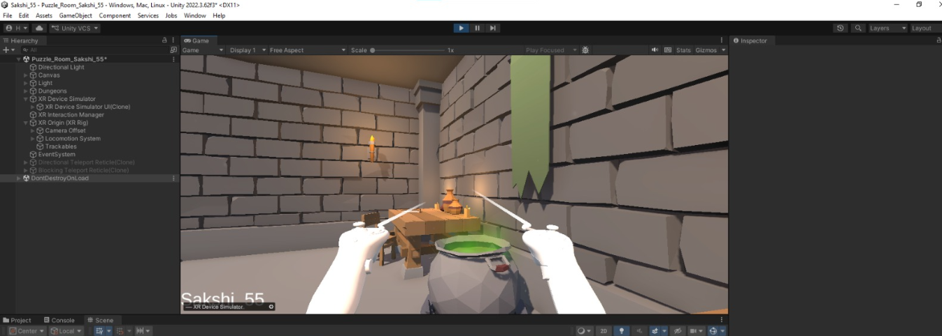

PRACTICAL-7: Object Interaction
Aim:
To create an interactive XR puzzle room environment in Unity and test object interaction using the XR Device Simulator.
Theory
Unity XR Interaction Toolkit allows users to interact with virtual objects in a VR environment. Interactive objects such as gems, treasure chests, and other game elements can be placed inside a scene and tested using the XR Device Simulator. This helps in developing and testing VR applications without requiring a physical VR headset.
Procedure
Step-1: Open the Puzzle Room Scene: Open the previously created Puzzle Room scene containing the XR setup and dungeon environment.
Step-2: Add Interactive Objects: Place the required game objects such as the treasure chest, gems, and other puzzle elements inside the scene.
Step-3: Arrange the Environment: Position the objects properly within the room and adjust their scale and placement as required.
Step-4: Configure XR Interaction: Ensure that the XR Origin, XR Device Simulator, and interaction components are properly configured.
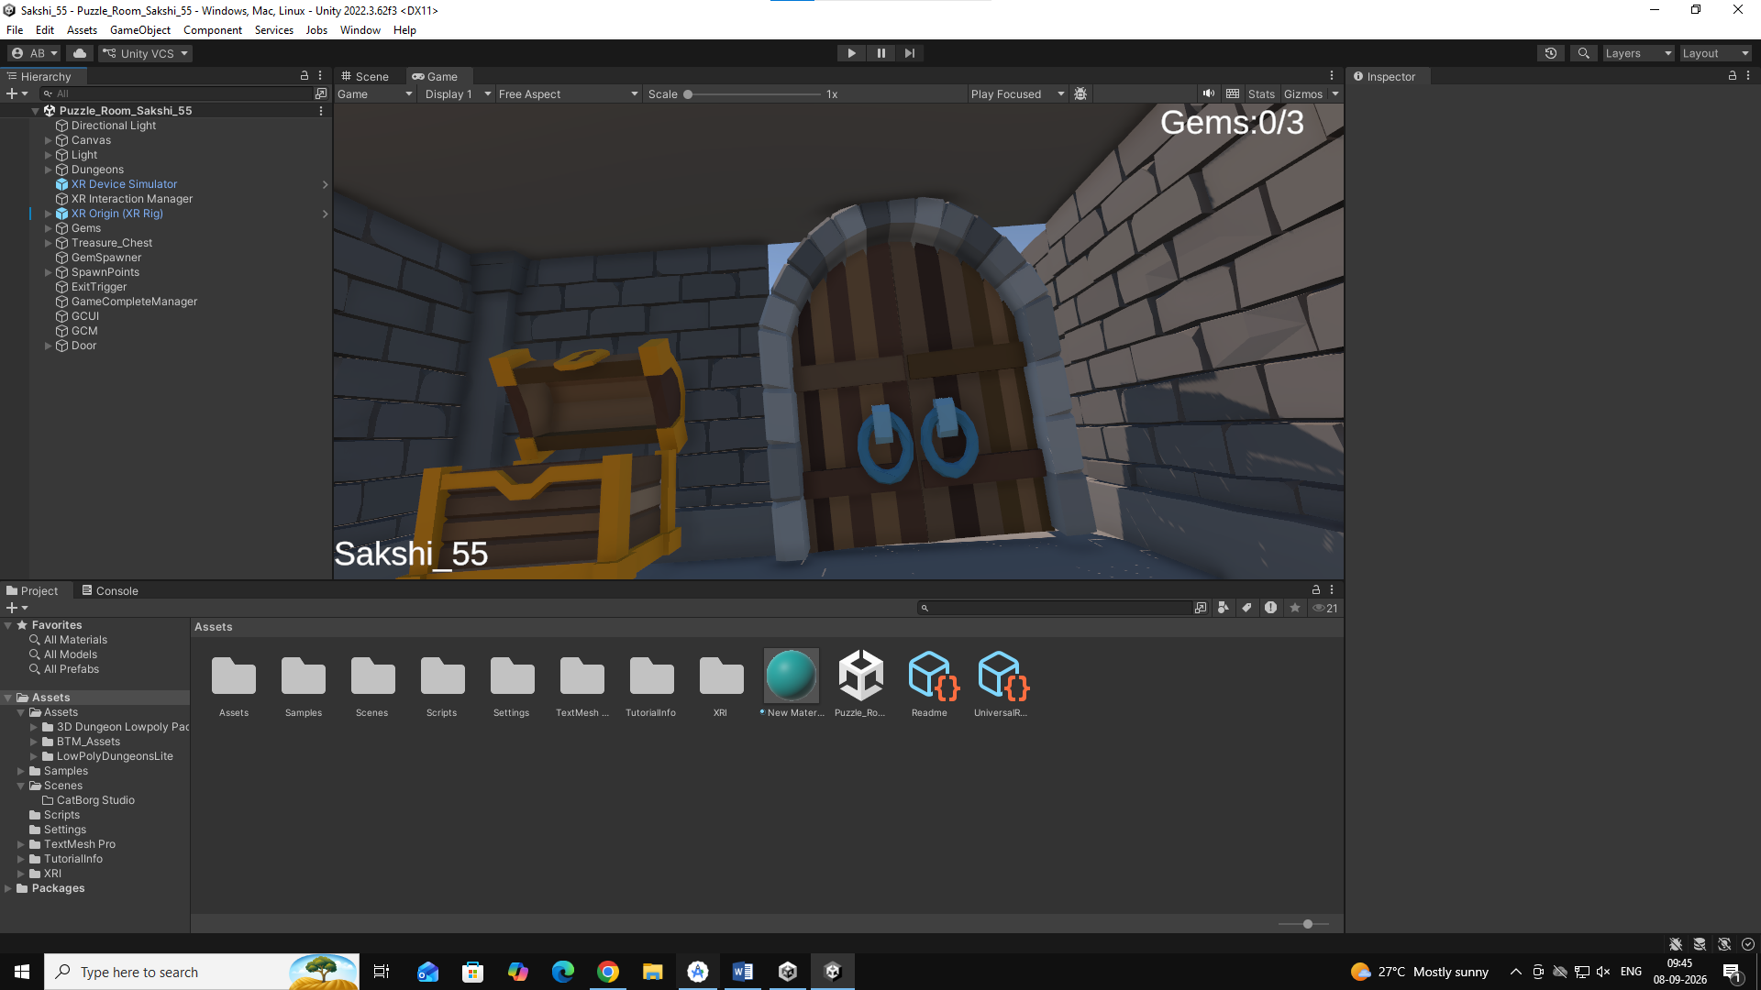

Step-5: Test the Scene: Click the Play button and use the XR Device Simulator to interact with the objects inside the puzzle room.
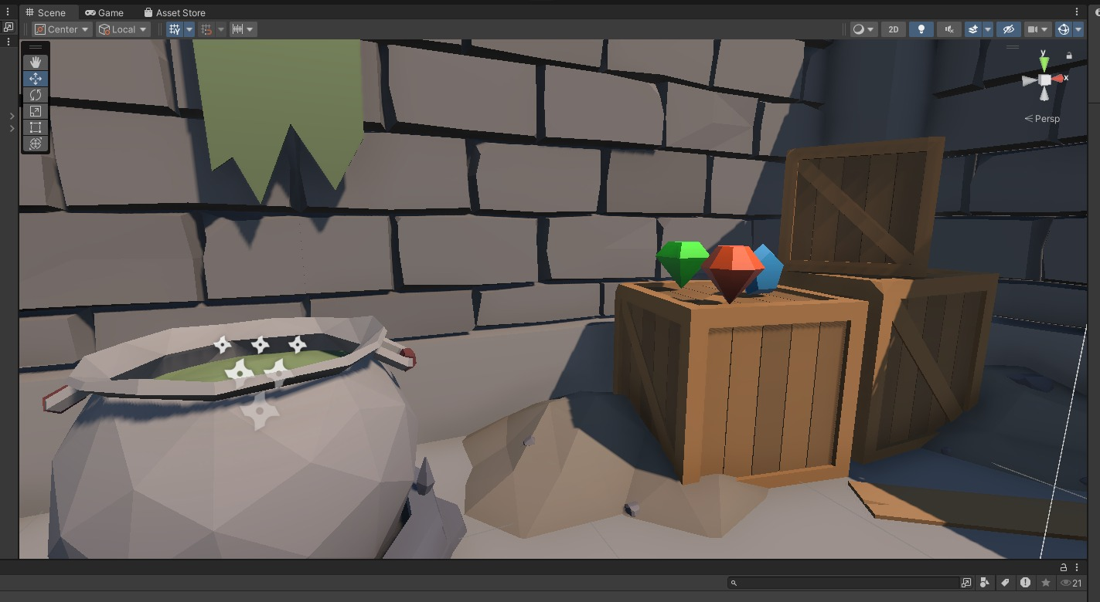

Code:
// GemSpawnManager.cs
using UnityEngine;
public class GemSpawnManager : MonoBehaviour
{
public GameObject[] Gems;
public Transform[] SpawnPoints;
void Start()
{ SpawnGems();
}
void SpawnGems()
{
// Create a list of available spawn points
System.Collections.Generic.List<Transform> availablePoints =
new System.Collections.Generic.List<Transform>(SpawnPoints);

for (int i = 0; i < Gems.Length; i++)
{
// Pick a random spawn point
int randomIndex = Random.Range(0, availablePoints.Count);
Transform selectedPoint = availablePoints[randomIndex];
// Move the gem to that point
Gems[i].transform.position = selectedPoint.position;
Gems[i].transform.rotation = selectedPoint.rotation;
// Make sure the gem is active
Gems[i].SetActive(true);
// Remove the selected point so another gem can't use it
availablePoints.RemoveAt(randomIndex);
}
}
}

PRACTICAL-8: Interactive UI
Aim
To create a Main Menu and Gem Counter system in Unity and connect the Main Menu with the Puzzle Room scene.
Theory:
Unity UI allows developers to create menus, buttons, and information displays for interactive applications. C# scripts can be used to control scene navigation and update UI elements dynamically. A gem counter can display the number of collected gems during gameplay.
Procedure:
Step-1: Create Main Menu UI: Open the Main Menu scene and add a Canvas from UI, then add the required raw image/background to the Canvas.
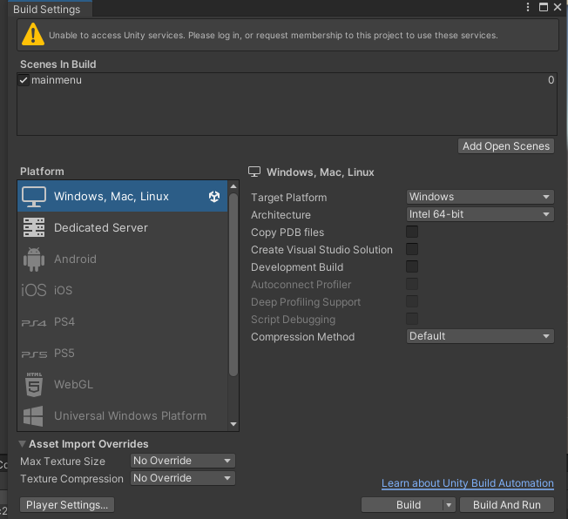
Step-2: Design Main Menu: Add and arrange the Start Game and Exit Game buttons on the Main Menu.
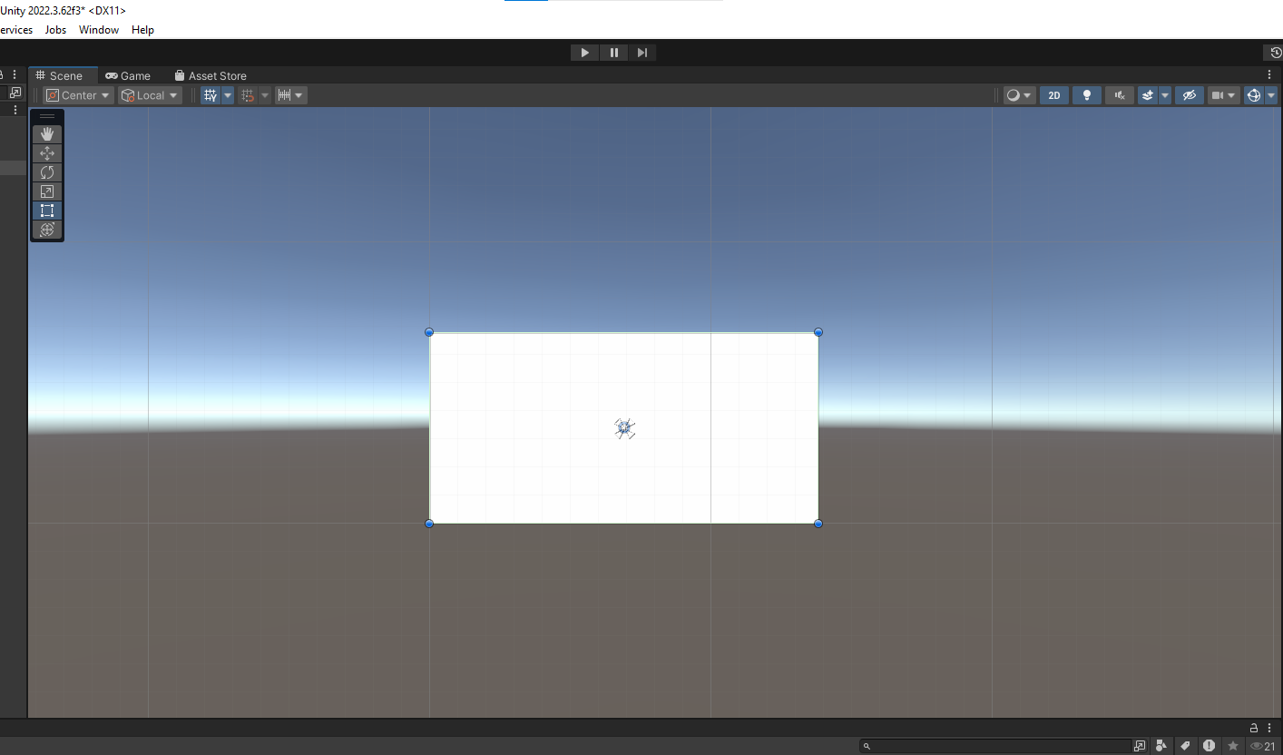 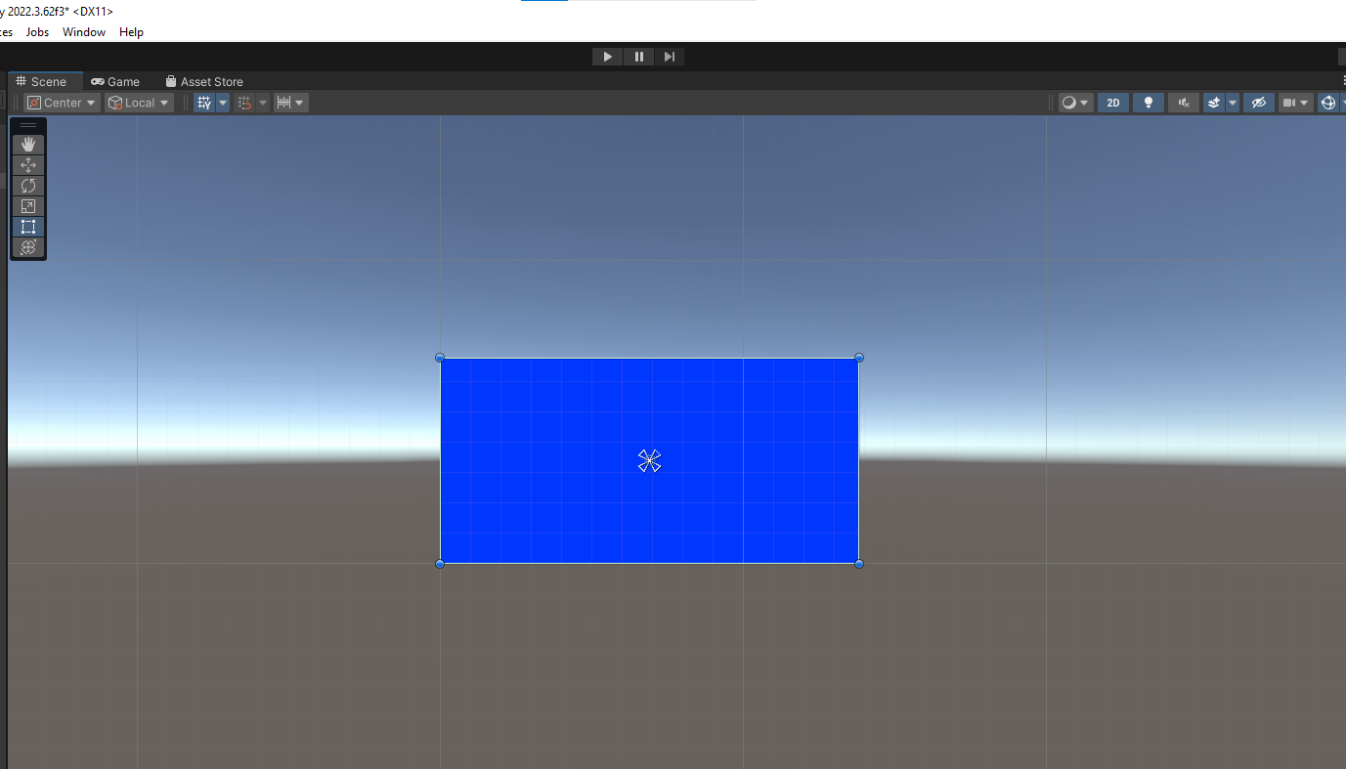
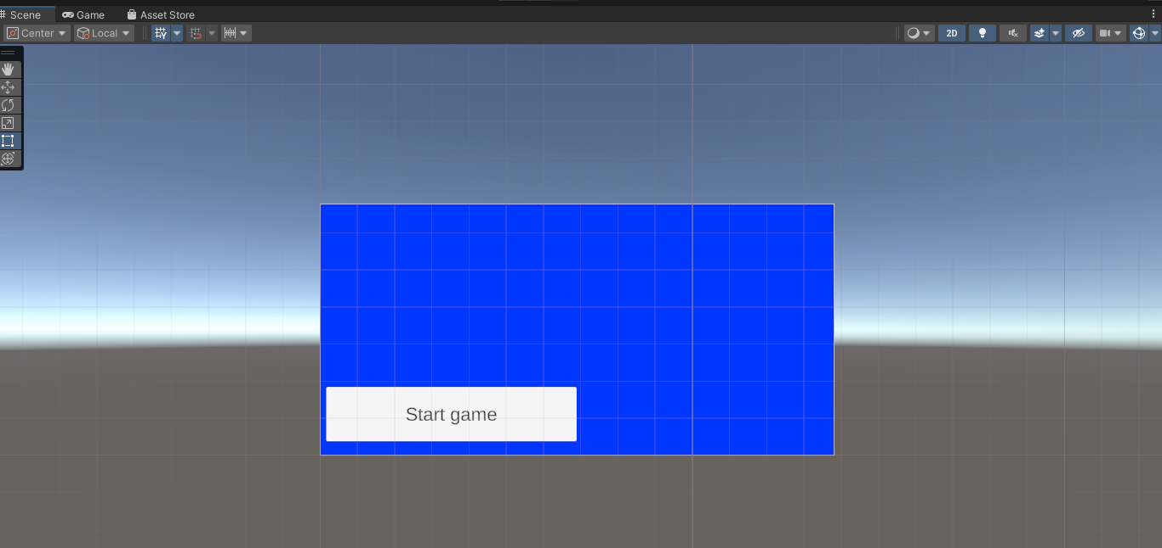
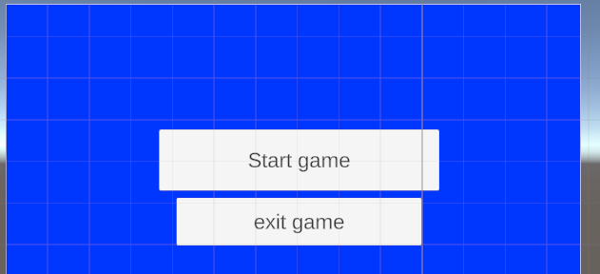
Step-3: Create Main Menu Script: Create a new C# script named MainMenuManager and open it for editing.
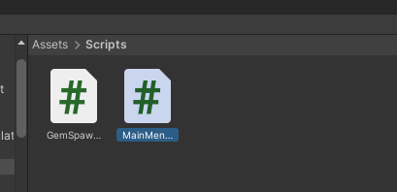

//MainMenuManager( script name )
using UnityEngine;
using UnityEngine.SceneManagement;
public class MainMenuManager : MonoBehaviour
{
public void StartGame()
{
SceneManager.LoadScene("Puzzle_Room");
}
public void ExitGame()
{
Application.Quit();
}
}
Step-4:Add Scene Navigation Code: Add the StartGame() and ExitGame() functions to load the Puzzle_Room scene and exit the application.
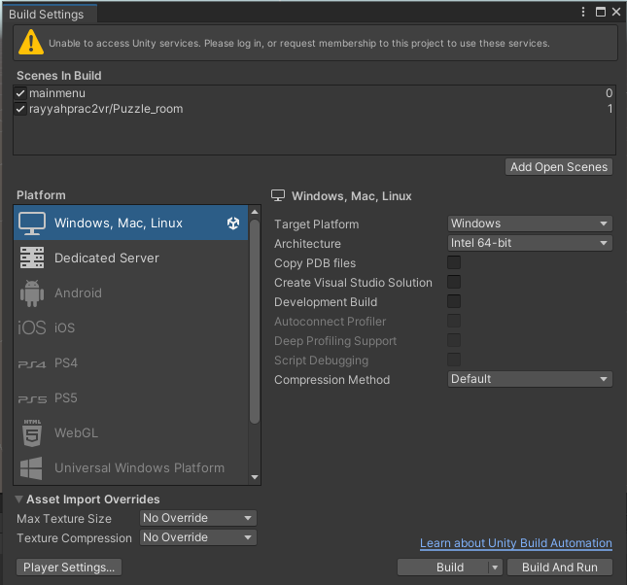
Step-5: Add Puzzle Room: Add the Puzzle Room scene to the Hierarchy/scene setup so that it can be accessed from the Main Menu.
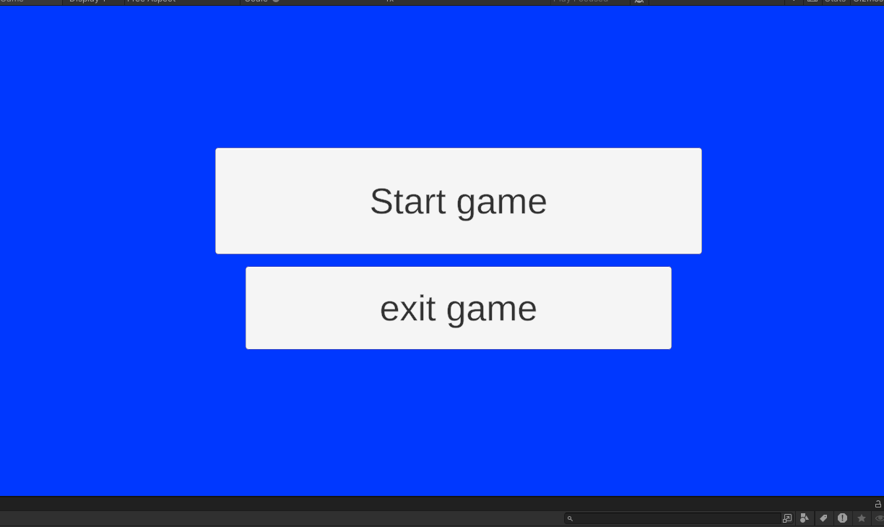
Step-6: Test Start Game: Run the Main Menu and click Start Game to verify that it takes the user to the Puzzle Room.
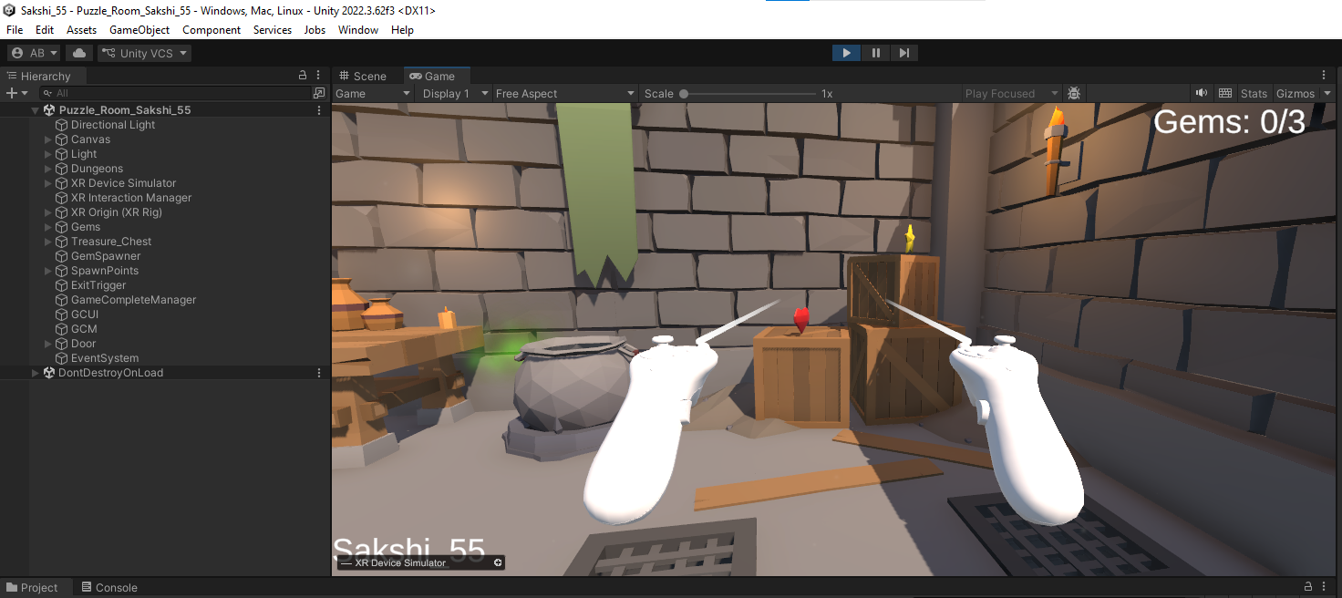
Step-7: Verify Scene Loading: Check that selecting Start Game successfully opens the Puzzle Room environment.
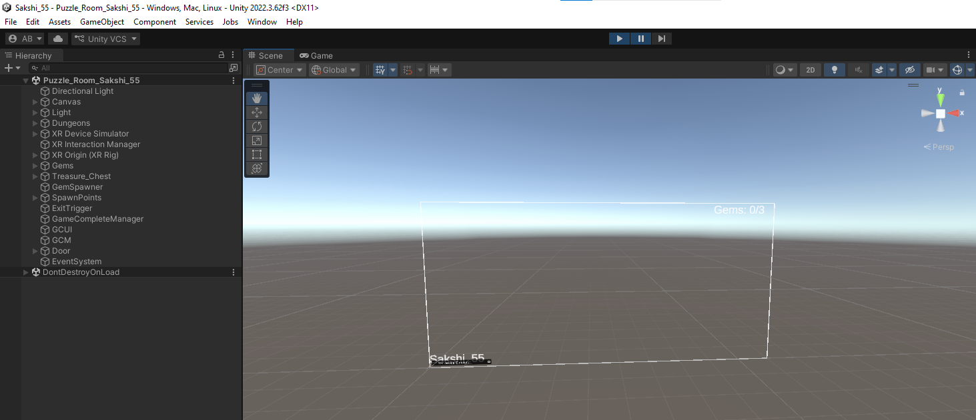
Step-8: Create Gem Counter Script: Create a new C# script named GemCounterUI.
//GemCounterUI
using TMPro;
using UnityEngine;
public class GemCounterUI : MonoBehaviour
{
public TextMeshProUGUI counterText;

public void UpdateCounter(int collected, int total)
{
counterText.text = "Gems: " + collected + "/" + total;
}
}

Step-9: Add Counter Code: Add the code to display the collected gems and total gems using TextMeshPro.
Step-10:Connect Counter UI: Add the script as a component and drag GameCounter from the Canvas in the Hierarchy into the required field in the Inspector.
Step-11:Create Gem Collection Manager: Create a new C# script named GemCollectionManager.
//GemCollectionManager
using UnityEngine;
public class GemCollectionManager : MonoBehaviour
{
public int totalGems = 3;
public int collectedGems = 0;
public GemCounterUI counterUI;
void Start()
{
UpdateUI();
}
public void GemPlaced()
{
collectedGems++;
if (collectedGems > totalGems)
{
collectedGems = totalGems;
}
UpdateUI();
}
public void GemRemoved()
{
collectedGems--;
if (collectedGems < 0)
{
collectedGems = 0;
}
UpdateUI();
}
void UpdateUI()
{
counterUI.UpdateCounter(collectedGems, totalGems);
}
}

Step-12: Add Collection Functions: Add the functions for updating the collected gem count, including GemPlaced, GemRemoved, and UpdateUI.
Step-13: Add Collection Manager: Add the GemCollectionManager script to the required GameObject.
Step-14: Configure Gem Sockets: Select the three game sockets, go to their Events section, add the required event options, and click + to configure the events.
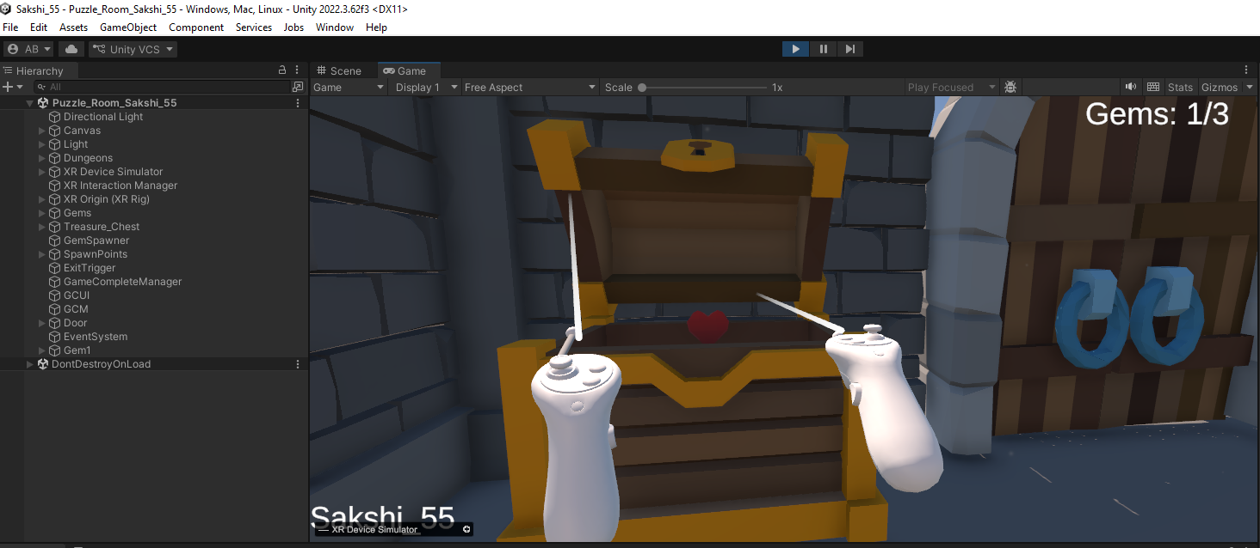

PRACTICAL-9: VR Walkthrough
Aim:
To implement a door-opening and game-completion system in Unity using C# scripts, triggers, and UI buttons for restarting or exiting the game.
Theory:
Unity allows game events to be controlled using C# scripts and trigger components. In this practical, collecting all gems activates the door, while an exit trigger displays the completion UI. The completion UI provides options to restart the game or quit the application.
Procedure:
Step-1: Create Room and Door: Create a room and add the required door from the available prefab.
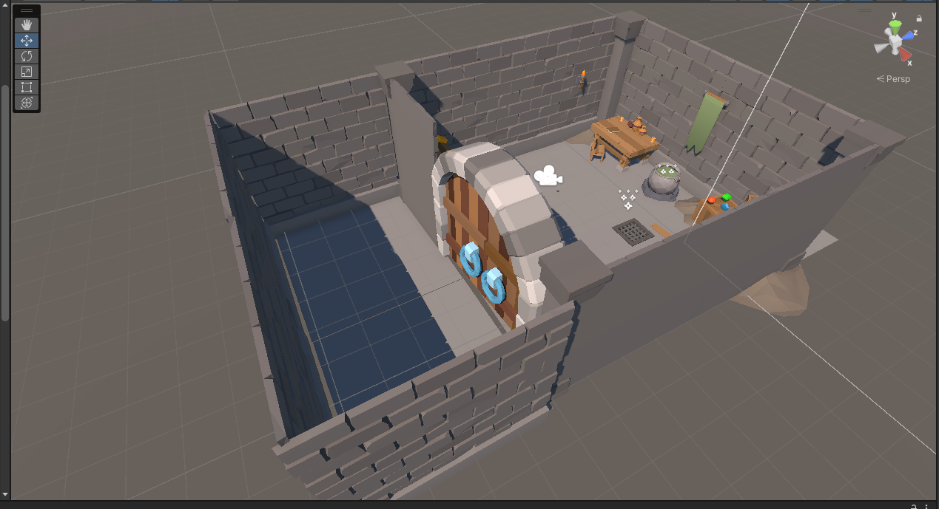
Step-2: Add Cutscene Camera: Add a camera to the scene and name it CutSceneCamera. Create the DoorController C# script and configure it with the left door, right door, and cutscene camera.
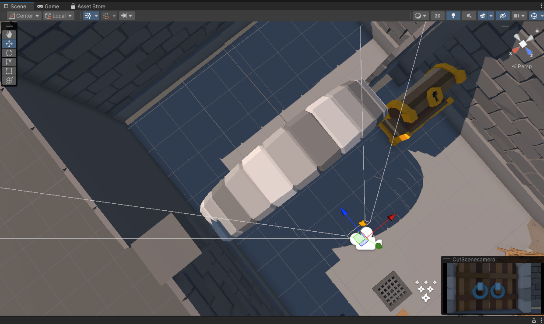
Step-3: Configure Door Opening: Add the door controller to the required GameObject and assign the left door, right door, and CutSceneCamera. Configure the script so that the doors open when the OpenDoors() function is called.
//DoorController

using UnityEngine;

public class DoorController : MonoBehaviour
{
public Transform leftDoor;
public Transform rightDoor;
public Camera cutsceneCamera;

bool open = false;
float timer = 0;

void Start()
{
cutsceneCamera.enabled = false;
}

void Update()
{
if (open)
{
timer += Time.deltaTime;

leftDoor.localRotation = Quaternion.Lerp(
leftDoor.localRotation,
Quaternion.Euler(0, -90, 0),
Time.deltaTime * 2
);

rightDoor.localRotation = Quaternion.Lerp(
rightDoor.localRotation,
Quaternion.Euler(0, 90, 0),
Time.deltaTime * 2
);

if (timer >= 3)
{
cutsceneCamera.enabled = false;
}
}
}

public void OpenDoors()
{
cutsceneCamera.enabled = true;
open = true;
}
}

Step-4: Connect Gem Collection: Configure the GCM so that collecting the required gems triggers the door-opening function.
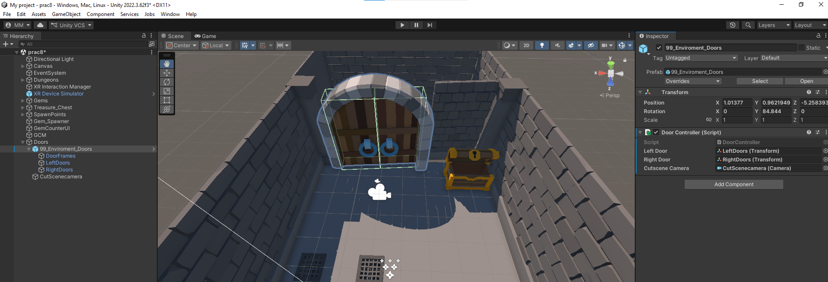

Step-5: Create Exit Trigger: Create a new empty GameObject named ExitTrigger and create an ExitTrigger C# script. Add a Box Collider, enable Is Trigger, and attach the ExitTrigger script to the GameObject.
Create a new game object as ExitTrigger
Create a new script as ExitTrigger
//ExitTrigger
using UnityEngine;
public class ExitTrigger : MonoBehaviour
{
public GameObject gameCompletionUI;
private void OnTriggerEnter(Collider other)
{
gameCompletionUI.SetActive(true);
}
}
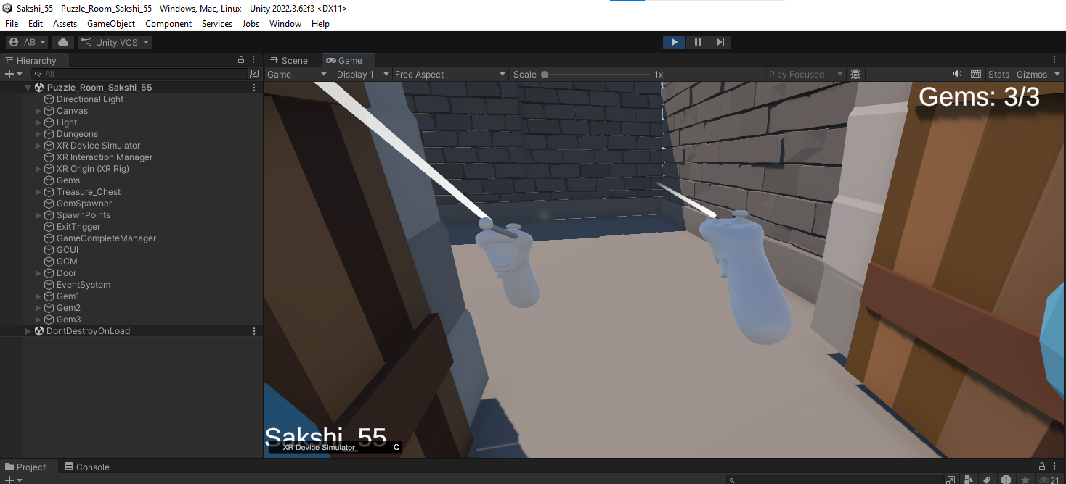
Step-6: Create Completion UI: Create an empty GameObject named CompletionUI. Add two UI buttons and name them Restart Game and Quit. Assign the CompletionUI to the ExitTrigger.
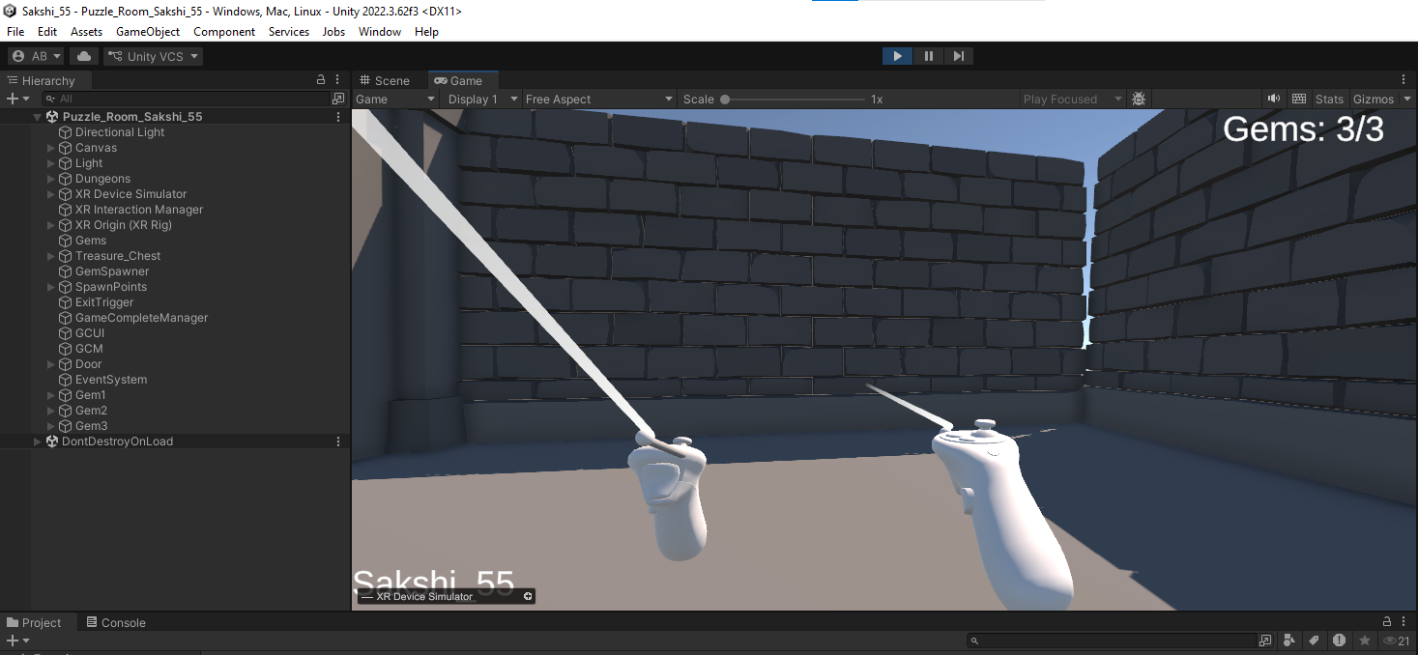
Step-7: Configure Game Completion: Create the GameCompleteManager script with Restart Game and Exit Game functions. Add the script to a new empty GameObject and configure the Restart Game button's OnClick event to call GameCompleteManager.RestartGame().
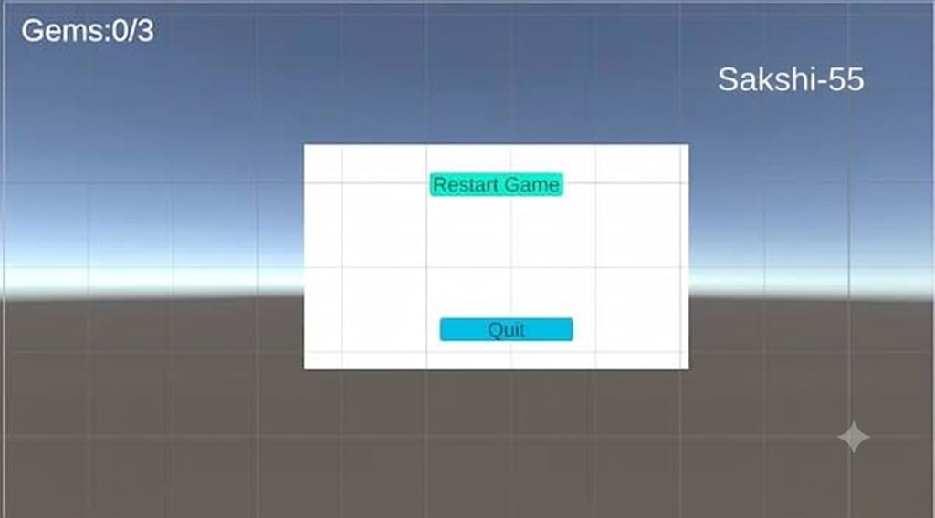

Add the completion ui to the exittrigger

Step-8:Create a new script as the GameCompleteManager
//GameCompleteManager
using UnityEngine;
using UnityEngine.SceneManagement;
{
public void RestartGame()
{
SceneManager.LoadScene(SceneManager.GetActiveScene().buildIndex);
}
public void ExitGame()
{
Application.Quit();
}
}
Step-9: Create the new empty in the hierarchy
And the script into it and then on the restart button onclick click plus and then add the object GameComplete and then GameCompleteManager.RestartGame
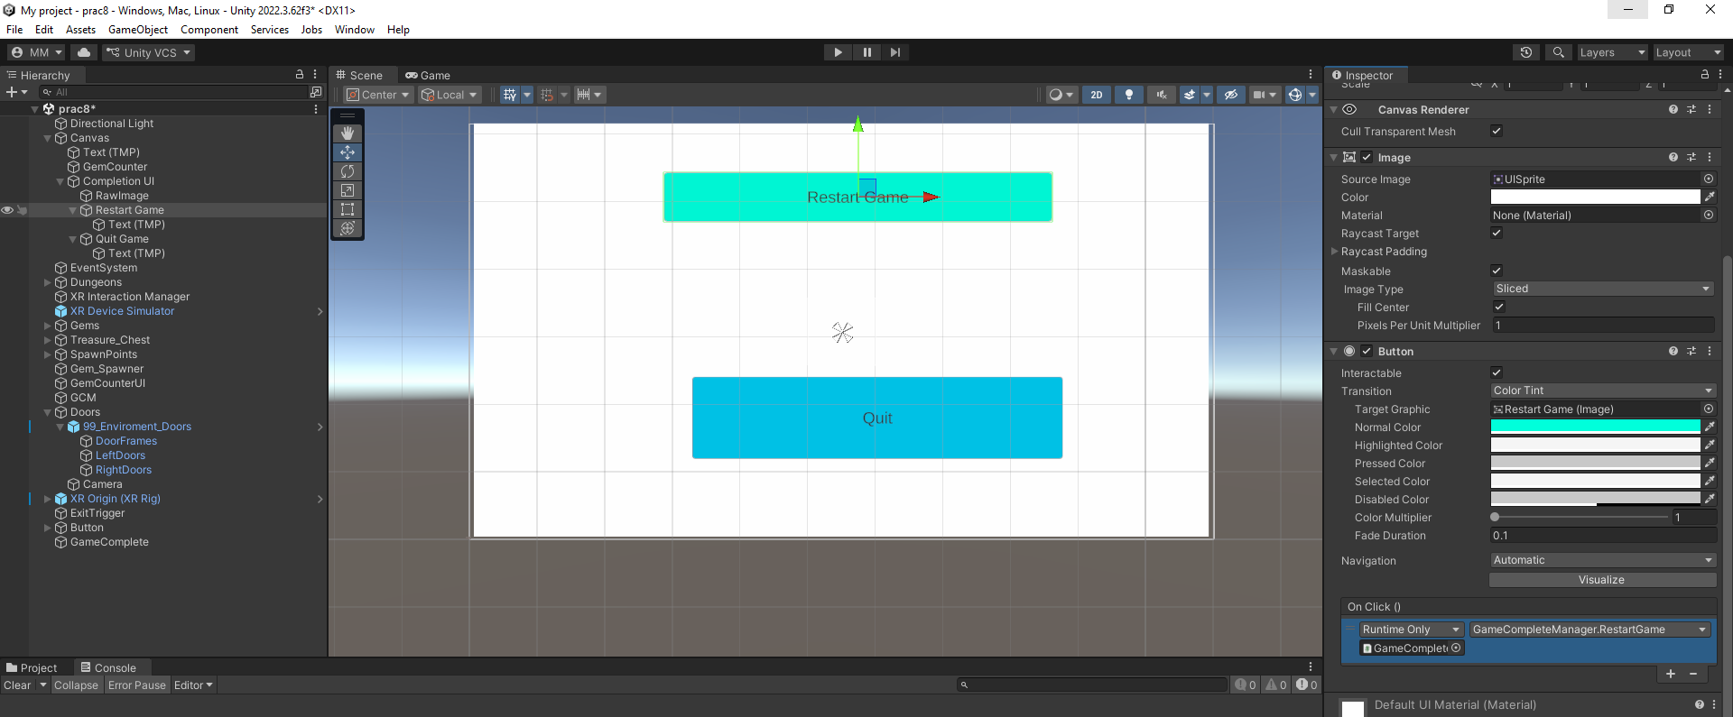

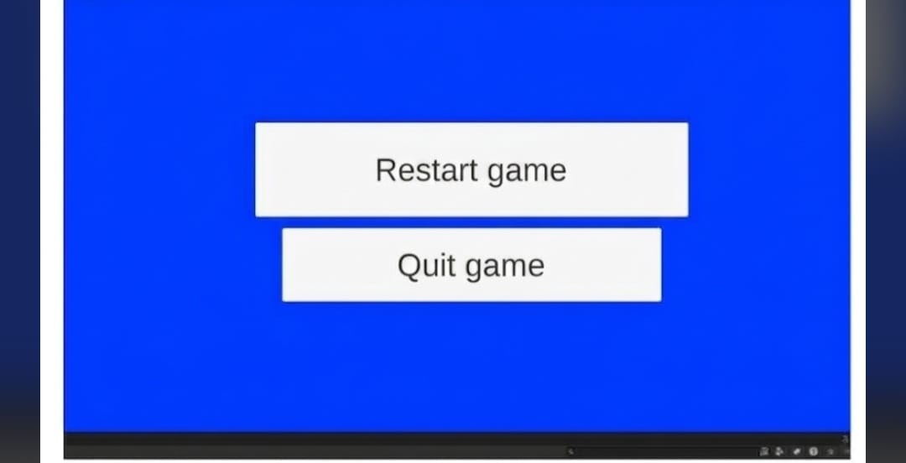

PRACTICAL-10: Mini VR Experience
Aim:
To create an interactive 3D environment in Unity containing different objects such as crates, tables, and a cauldron.
To display relevant information about selected objects within the Unity scene.
Objectives
- To design and arrange a basic 3D environment using Unity objects and assets.
- To add interactive objects such as crates and a cauldron to the scene.
- To display object-related information such as weight, contents, physics, and status.
- To test the scene and verify that the required information is displayed correctly.
Procedure
Step-1: Open Unity Hub and create or open the required 3D Unity project.
Step-2: Create the basic 3D environment by adding objects such as walls, floor, tables, benches, and other required elements.
Step-3: Arrange the objects properly in the scene to create an organized 3D environment.
Step-4: Add interactive objects such as a wooden crate and a cauldron to the environment.
Step-5: Configure the crate object and provide its required properties, such as weight, contents, and physics information.
Step-6 :Configure the cauldron object and define its properties, including its status, contents, and last-used information.
Step-7: Add the required UI/information display so that information about an object can be shown when it is selected or interacted with.
Step-8: Test the crate interaction and verify that information such as Weight: 10 kg, Contents: Simple Primitives, and Physics: Active is displayed.
Step-9: Test the cauldron interaction and verify that information such as Status: Empty, Contents: (Null), and Last used: (Null) is displayed.
Step-10: Run the Unity scene and check that all objects, interactions, and information panels are working correctly.
Step-11: Save the Unity project and scene after confirming that the complete 3D environment and object information are displayed properly.
